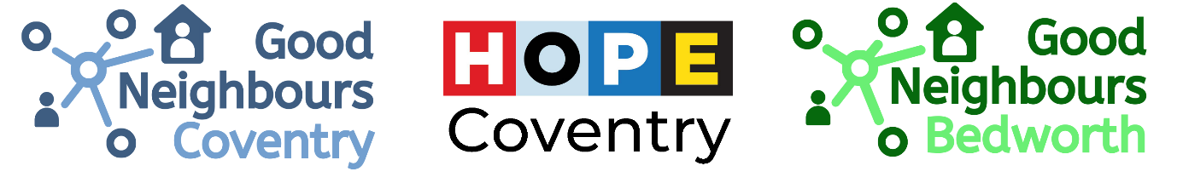
Good Neighbours referral form (April 2023 version)
We offer 1:1 befriending for isolated over 50s living in Coventry CV1-CV6. There is significant demand for the service, and a waiting list may be in place. We no longer offer a service in Bedworth.
The 1:1 service is primarily aimed at older people who are housebound. Those who live alone will be prioritised.
Clients can now choose between socially distanced home visits, phone calls, socially distanced walks, or postal befriending (pen pals). Most volunteers do not go out e.g. to town with their older person.
The befriender visits or phones on average weekly or fortnightly for 30-60 minutes.
We are constantly refreshing our CV1-CV6 Activity Guides to help people access friendship groups. Email us for new copies. We are also running specialist groups for men living with poor mental health, and people living with dementia & their carers.
Criteria for 1:1 befriending: The older person must actually want a befriender, be aged over 50, not living in a care home, and not experiencing severe mental illness.
The ideal client to match is:
- housebound, living alone
- a non-smoker, in a sanitary home
- age 75+
- flexible on when they have a visitor
- welcoming
- has a good enough memory to remember the volunteer
- will engage with conversations on different topics.

Clients who don’t fit this profile will take longer to match because they are usually less appealing to a volunteer befriender.
The client must not pose a risk to volunteers through threatening, unsafe or discriminatory behaviour; criminal history; or unsafe home circumstances. We cannot facilitate two-person visits.
Volunteers do not provide personal care, respite care, or shopping.
We can’t guarantee support to everyone – we are volunteer dependent and there is significant demand for the service. Referrals are processed on weekdays. It normally takes several weeks to find someone the right befriender for them.
We’ll try to help however we can; ask us if we can help in various situations.

Name of client
Address of client
Phone number
Email address (if applicable)
Primary language spoken (if not English)
Date of birth
Complexities about client  Please give details for any of these present | Dementia  Learning disability  Mental health issues  Poor mobility  Visual impairment / illiterate  Hearing impairment  Domestic abuse  Alcoholism / drug addiction  Criminal history  Other factor e.g. recent bereavement, personality
Client’s home circumstances e.g. living alone, living with partner
Are there animals in the house?
Client’s emergency contact name, relationship & phone number |  |  | Name & relationship:  Phone number:
Client’s GP surgery
Are any other organisations regularly supporting the client?
Other than loneliness, any other relevant information about them?
Have you met the client before? |  |  |  | Yes / No
Is a 2 person visit required? |  |  |  | Yes / No
Referral for home befriending? |  |  |  |  |  | Yes / No
Referral for group clubs and activities? |  |  |  |  |  | Yes / No
Referral for phone befriending? |  |  |  |  |  | Yes / No
Referral for other help (please state)? |  |  |  |  |  | Yes / No
Which other organisations are you referring client into? (to avoid duplication)
Name of referrer, organisation, and contact
Date of referral

This form should be returned to Jess Day-Pollard, Good Neighbours Project Manager, by email to goodneighbours@hopecoventry.org.uk . For more information, contact Jess by email or phone: 07563 902 904. Website: hopecoventry.org.uk/projects/good-neighbours-coventry/ and facebook.com/goodneighbourscoventry

Information for those being referred to Good Neighbours Coventry
What is Good Neighbours Coventry befriending?
- We match you to a volunteer we think you’d get on with.
- The purpose of the volunteer is to chat with you, to make you feel less lonely.
- The volunteer is police checked.
- The volunteer phones or visits, weekly or fortnightly.
- Most volunteers work, so will call or visit flexibly.
- Some volunteers might do a hobby at your home with you e.g. jigsaws, craft, chess.
- Some volunteers might go on a short local walk with you.
- Although volunteers are there to help you, please give them some cheery conversation as well as your worries! We hope that the friendship will flow in both directions.

What Good Neighbours Coventry befriending isn’t
- Volunteers are NOT trained counsellors – they are ordinary folk from the community.
- Volunteers can’t replace mental health professionals.
- Volunteers are not taxi drivers.
- Volunteers aren’t there to do errands for you.
- Most volunteers won’t go out e.g. to town/groups with you.
- Volunteers are not carers. They are not ‘on-call’.
- Volunteers can’t sort appointments for you.

For further clarification or help with other things, contact: 07563 902 904 or goodneighbours@hopecoventry.org.uk or write to Good Neighbours, The Halo Centre, Progress Way, Binley, Coventry, CV3 2NT

